Name :SK.Kashifa

Registration no :192121135

Doctor’s appointment system

Class diagram :

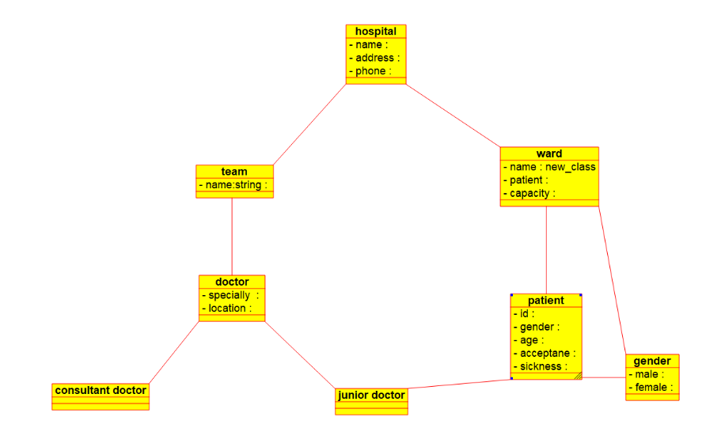

Sequence diagram :

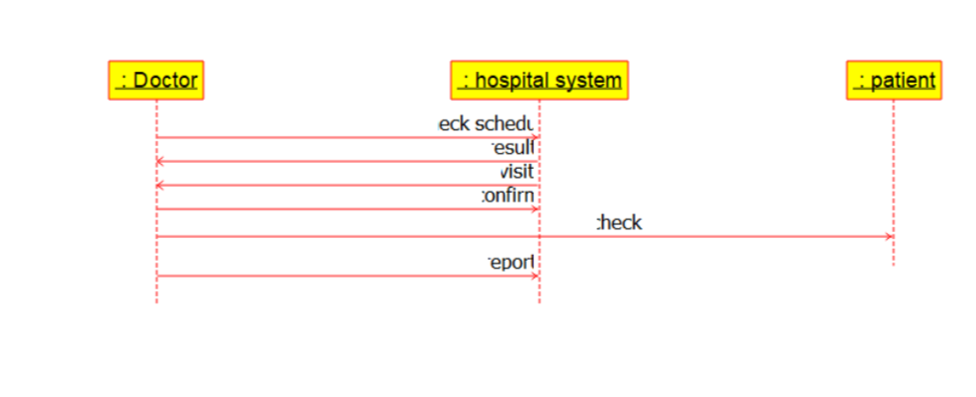

Deployment diagram :

